1. xplain all the features or functions of Trello in relation to your 7th-semester project and managing it effectively.
   1. Creating Boards: Begin by creating a Trello board for your project. Please attach a screenshot of the process showing how you create the board.
      1. Go to Trello and Login.

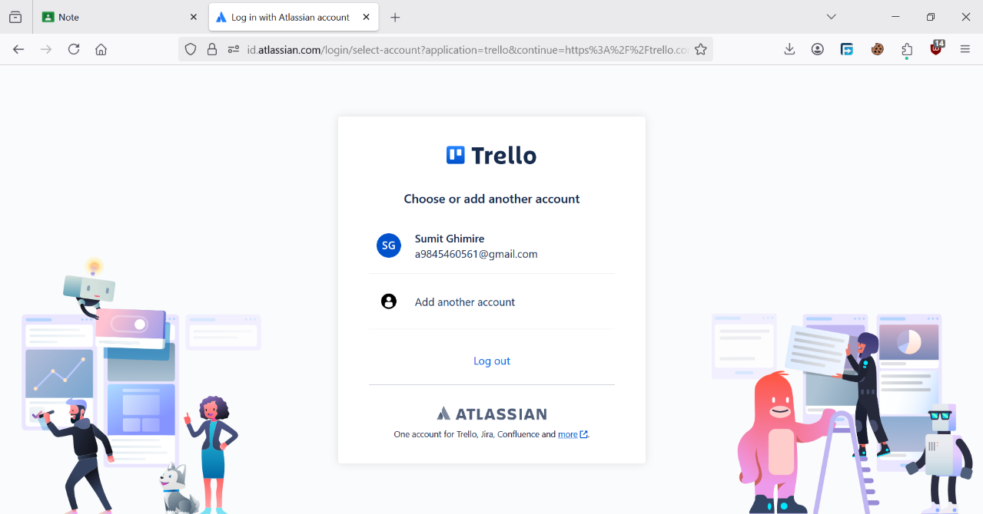

* + 1. Click on the **Create new board** option.

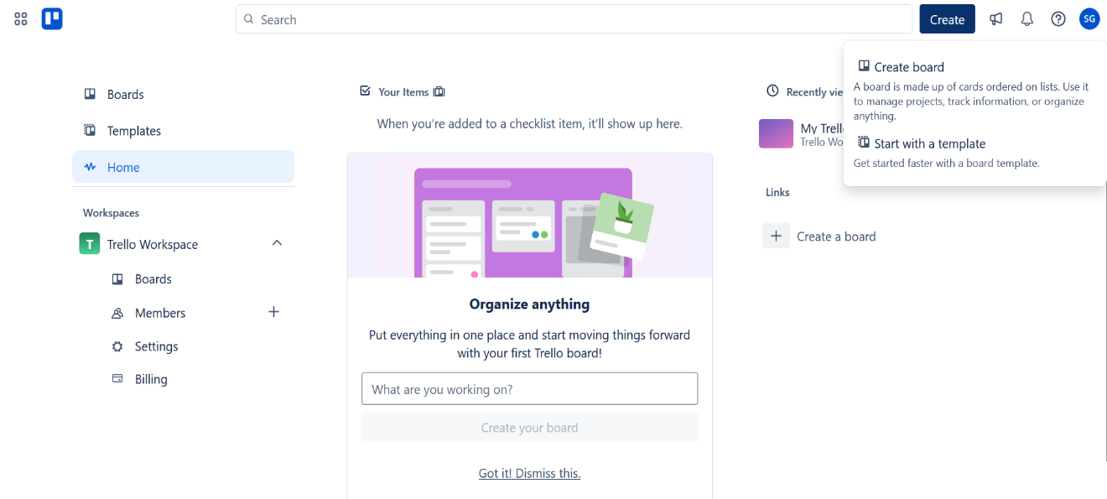

* + 1. Name the board something relevant.

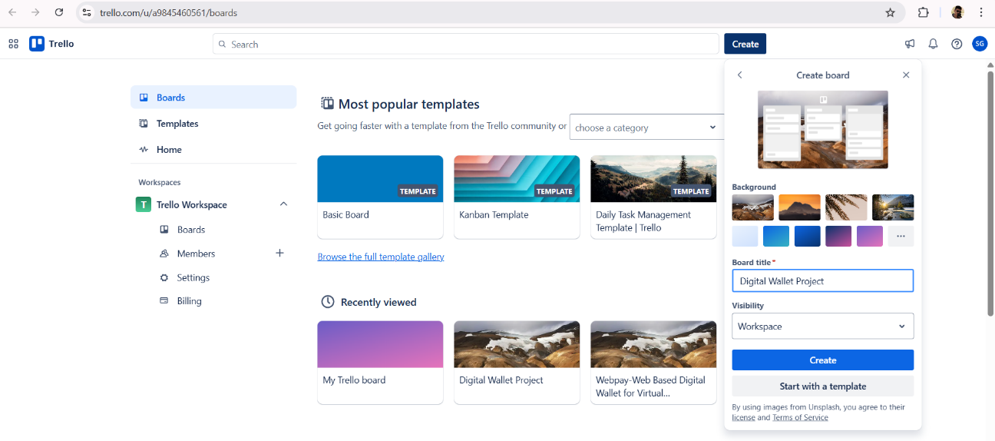

Optionally, choose a background color or theme to personalize the board.

* + 1. Click **Create Board** to finish.

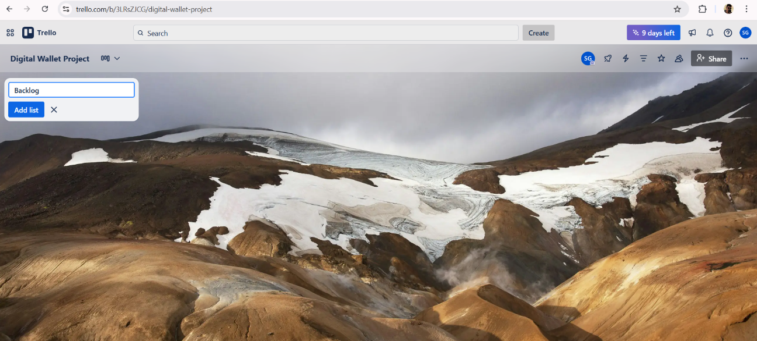

* 1. Lists and Cards: Within your Trello board, you can create lists to represent different stages or categories of your project. For instance, you might have lists for To-Do, In Progress, and Done.
     1. Add Column by clicking on 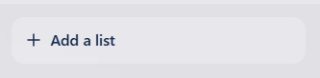 button.

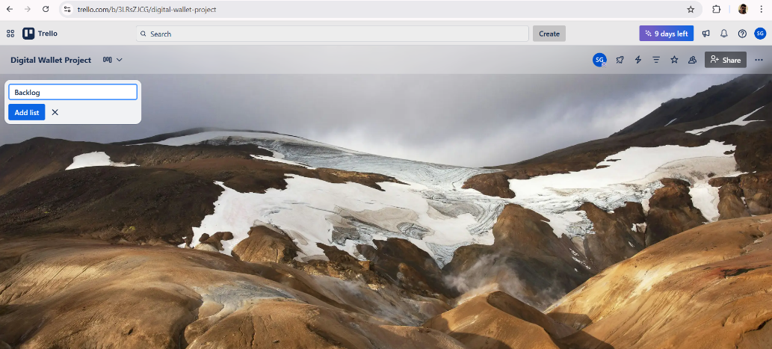

* + 1. Add other columns by clicking on  button.

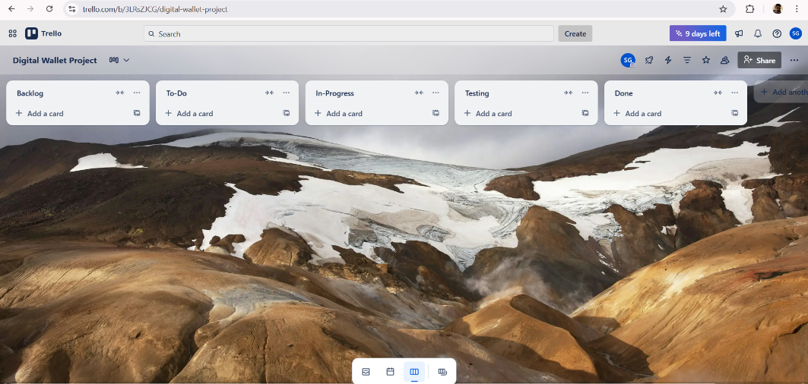

* + 1. After the columns has been added, create cards for respective columns.

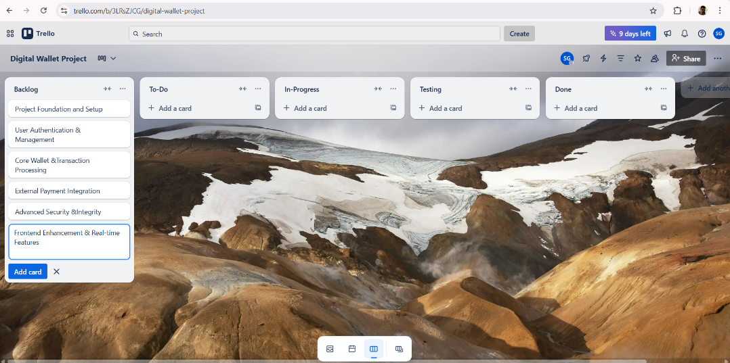

* 1. Task Management: Utilize Trello cards to represent individual tasks or activities within your project. You can add descriptions, checklists, due dates, attachments, and labels to cards to provide more information and context.

Adding Description:

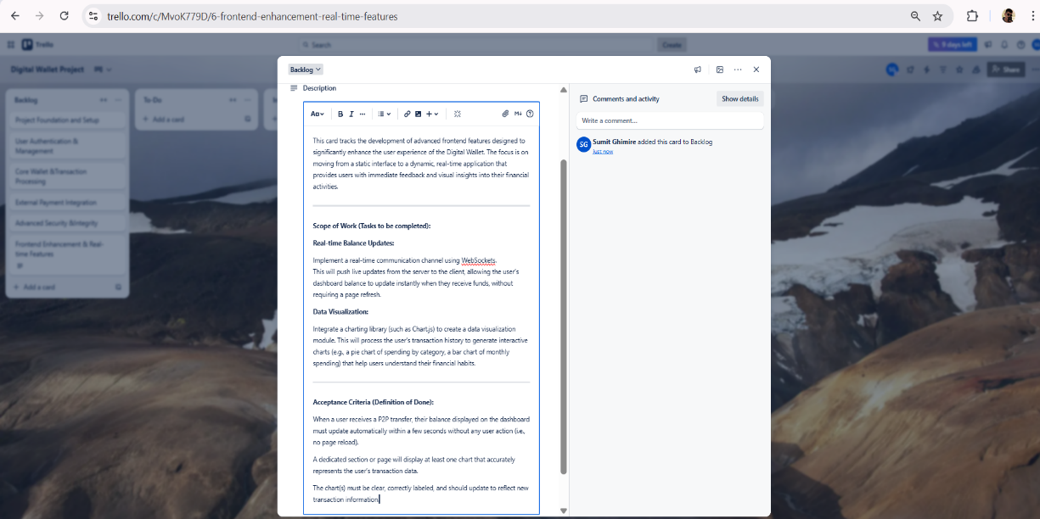

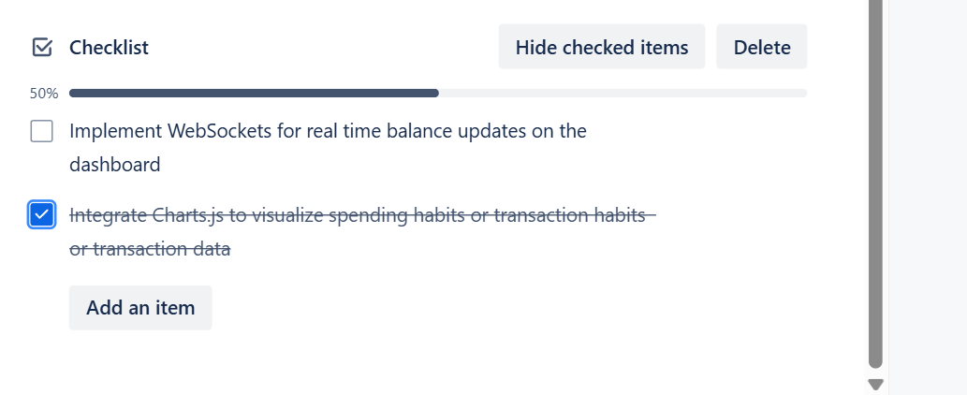Adding Checklists:

Adding Due Date:

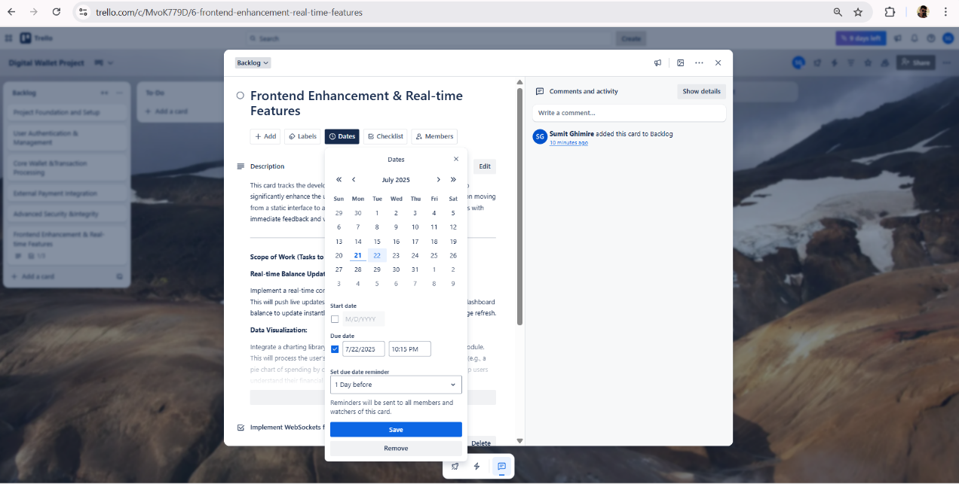

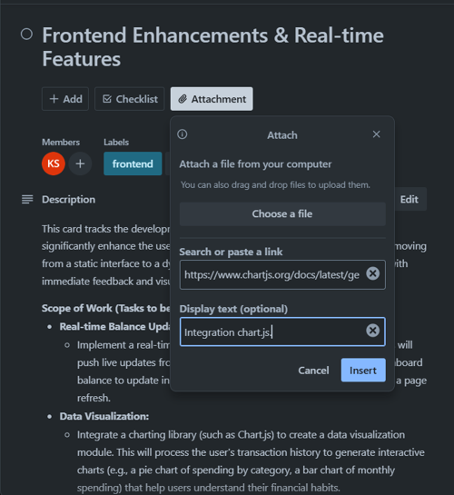Adding Attachments:

Adding Labels:

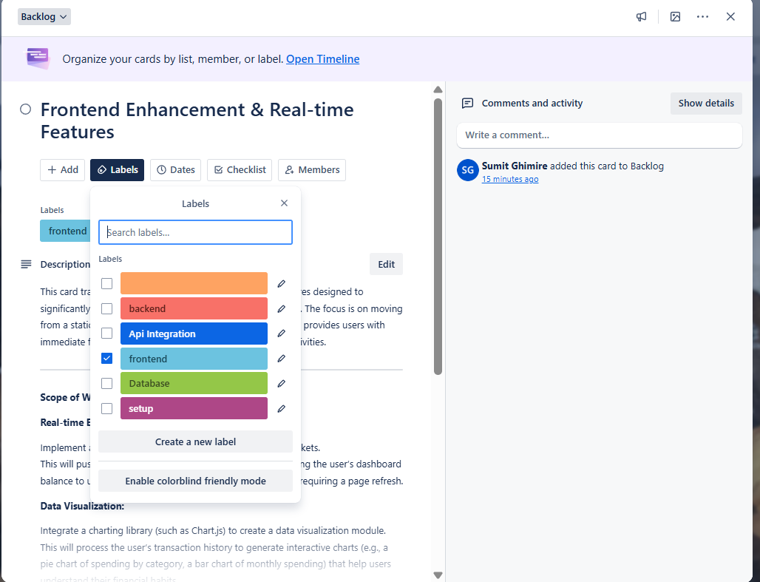

* 1. Assigning Tasks: Assign tasks to team members by adding them as members to specific cards.

Adding team members to workspace.

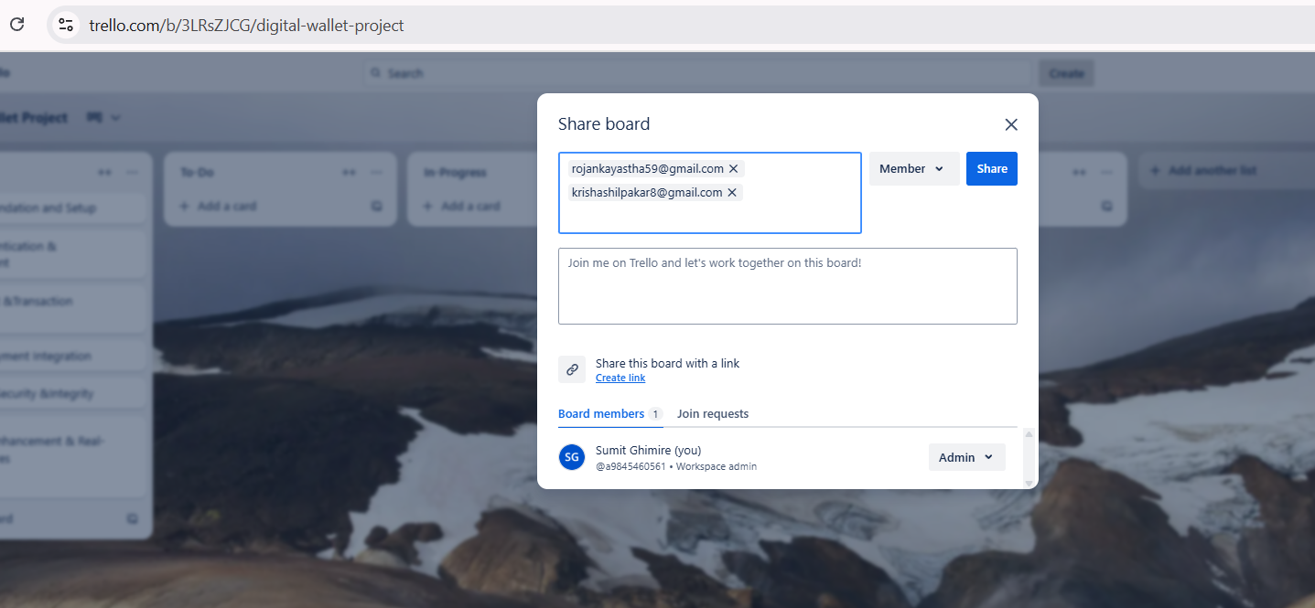

Assigning team member to perform task in the card.

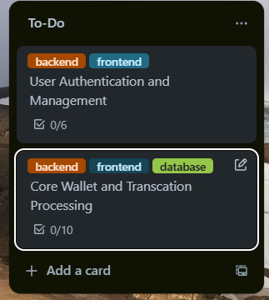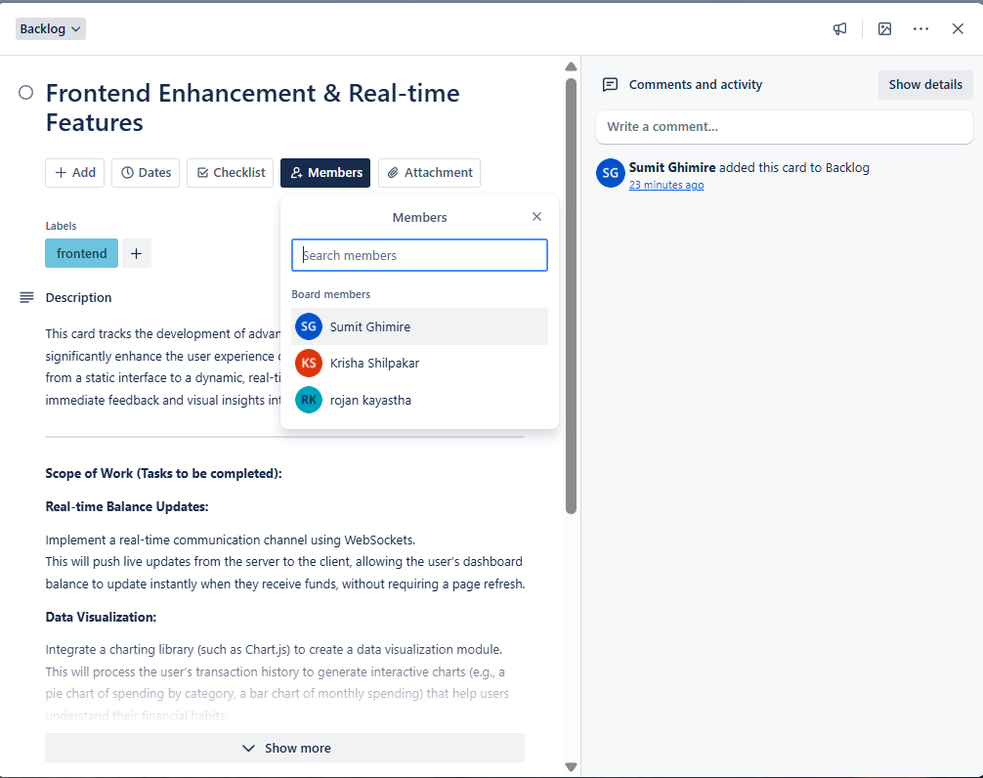

* 1. Collaboration: Team members can leave comments, mention each other, and attach files to cards to discuss specific tasks or issues.

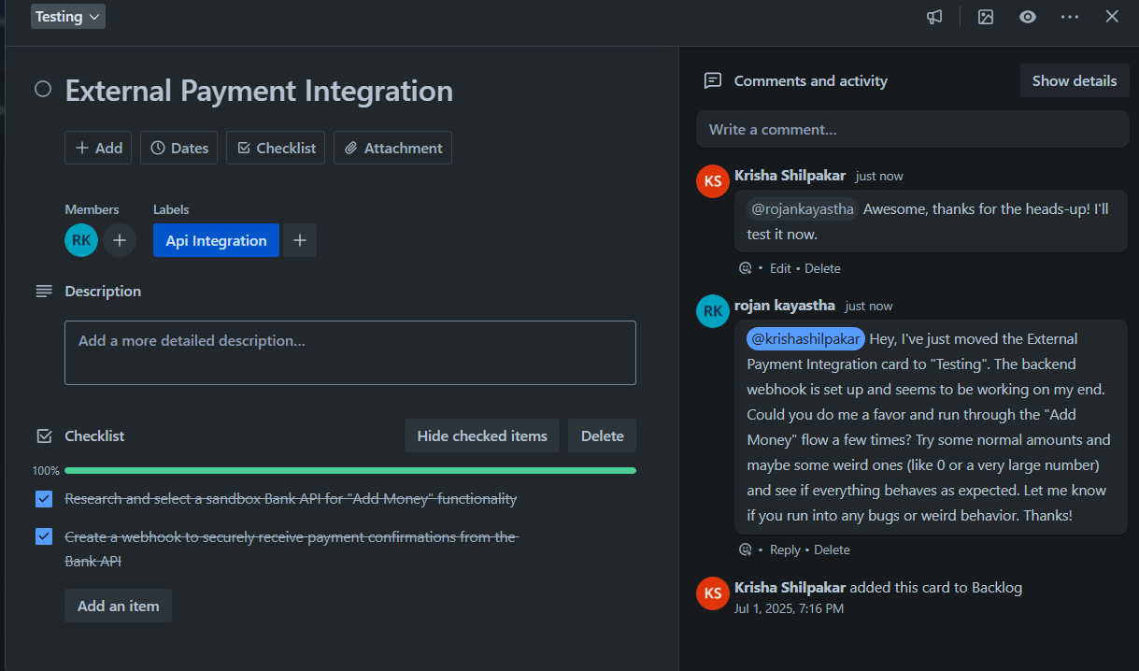Mentioning team members in comment

* 1. Prioritization: Utilize Trello's drag-and-drop interface to prioritize tasks within lists. You can reorder cards based on their importance or urgency to ensure that the most critical tasks are completed first.

Prioritize task within the column by reordering.

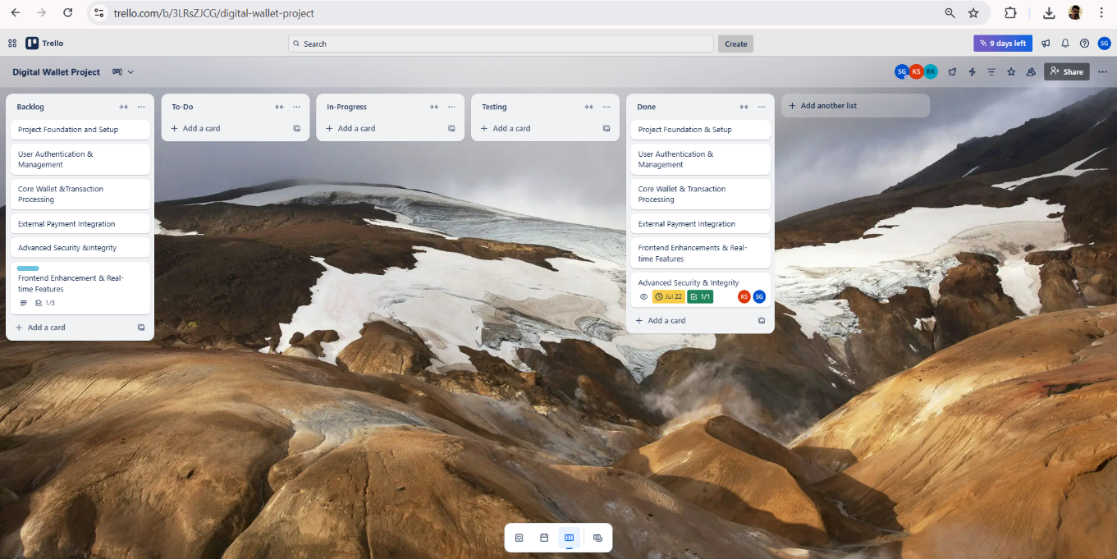

* 1. Tracking Progress: Trello provides visual cues to track the progress of your project. As tasks move through different lists, you can see at a glance how much work has been

completed and what still needs to be done

Trello offers various ways to visually track the progress of a project, ensuring tasks are

managed effectively and deadlines are met. These tools provide flexibility and insights into the project's overall status. Here are some of the key features for tracking progress:

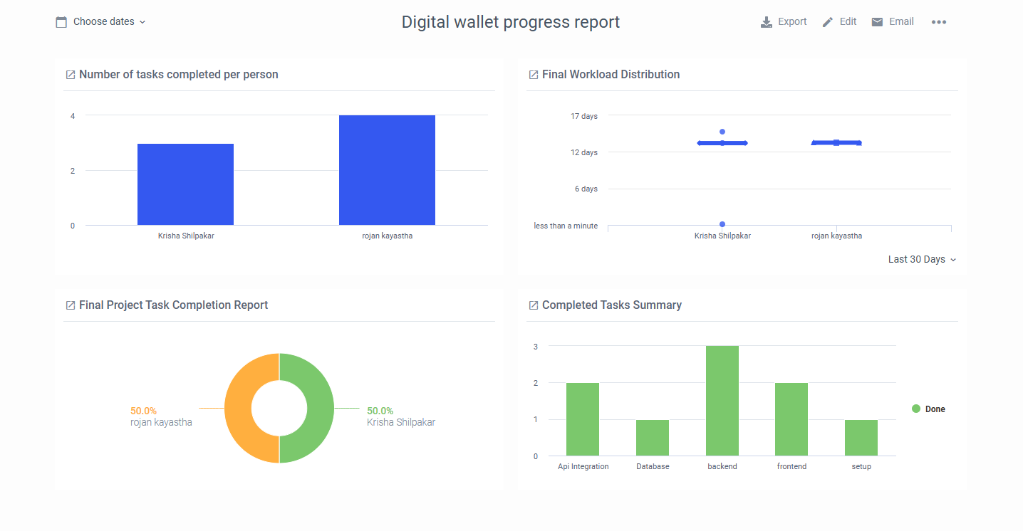

# What is a Precedence Diagram Method?

Precedence Diagram Method (PDM) is a visual representation technique that depicts the activities involved in a project. It is a method of constructing a project schedule network diagram that uses boxes/nodes to represent activities and connects them with arrows that show the dependencies. It’s also sometimes called the activity-on-node (AON) method.

The purpose of the Precedence Diagram Method is to produce a more accurate scheduling network diagram. The Program Evaluation and Review Technique (PERT) and Critical Path Method (CPM) techniques are essentially limited to “finish-start” relationships (i.e., activity B cannot start until activity A is completed). PDM was developed after the PERT/CPM techniques, and its function is to permit a more accurate depiction of relationships among various activities.

The Precedence Diagram Method (PDM) is a way to schedule activities in a project by showing them on a scheduled network diagram. It is a way to show how activities relate to each other logically and to make a project schedule network diagram. Some important things to remember about using the PDM are:

* PDM is a useful tool for planning and scheduling projects because it makes it easy to see how different tasks relate to each other and in what order they should be done.
* PDM is based on the idea of priority, meaning that some things must be done before others can start. This is shown in the diagram by showing how activities depend on each other.
* PDM can be used to make a project schedule that shows when each task will begin and end. This helps find the project’s critical path, which is the order of tasks that determines how long the whole project will take.
* PDM can help find problems or bottlenecks in a project’s schedule and make plans to deal with them.
* PDM can be used with other tools and techniques for project management, like the critical path method, to help plan and manage projects better.

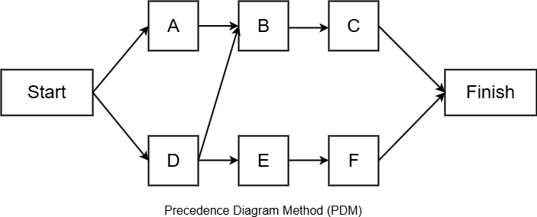

The PDM has four ways of developing the diagram. These methods are:

1. **Finish-Start:** In this dependency, an activity cannot start before a previous activity has ended. This is the most commonly used dependency.
2. **Start-Start:** In this dependency, there is a defined relationship between the start of activities.
3. **Finish-Finish:** In this dependency, there is a defined relationship between the end dates of activities.
4. **Start-Finish:** In this dependency, there is a defined relationship between the start of one activity and the end date of a successor activity. This dependency is rarely used.

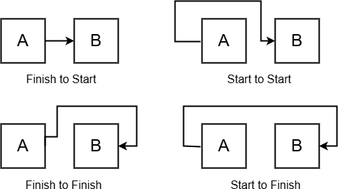

# What is a Gantt Chart and Network Diagram? Gantt Chart

A Gantt chart is a visual tool used in project management to schedule, plan, and track tasks. It consists of a horizontal timeline that displays tasks as bars, with the length of each bar representing the task's duration and its position indicating the start and end dates. Tasks are listed vertically, making it easy to see the sequence of activities. Dependencies between tasks are often shown using arrows or lines, highlighting the relationships and flow of the project. Milestones, which signify significant events or deliverables, are marked separately, typically as diamond shapes. Gantt charts are commonly used to track progress, as bars can be shaded or color-coded to show completion status. They are valuable for organizing tasks, visualizing dependencies, and communicating project schedules to stakeholders. However, for larger projects with many tasks, they may require careful management to remain clear and up-to-date.

Features of a Gantt Chart:

1. Timeline:
   * The chart typically has a horizontal time axis, divided into days, weeks, months, or other relevant intervals.
   * Tasks are plotted on this timeline to indicate their start and end dates.
2. Activities:
   * Tasks are listed vertically on the left side of the chart.
   * Each task is represented by a horizontal bar.
3. Bars Represent Task Duration:
   * The length of each bar corresponds to the duration of the task.
   * The position of the bar shows the task's start and finish dates.
4. Dependencies:
   * Arrows or lines can connect tasks to show their dependencies and sequences.
5. Milestones:
   * Key points or significant events in the project are marked as milestones, often with a diamond shape.
6. Progress Tracking:
   * Bars can be shaded or color-coded to indicate progress on each task.

# Network Diagram

A network diagram is a visual representation of a project’s activities, tasks, or events, organized to illustrate their sequence, dependencies, and relationships. It is a key tool in project management, often used in planning, analyzing workflows, and determining the critical path in projects. It consists of nodes, which represent tasks or events, and arrows that indicate the flow and dependencies between them. The diagram helps illustrate the logical order of activities, making it easier to understand how tasks are interconnected.

There are two main types:

**Activity-on-Node (AON)**, where nodes represent tasks and arrows show dependencies.

**Activity-on-Arrow (AOA)**, where arrows represent tasks and nodes signify events.

Network diagrams are commonly used for scheduling, resource allocation, and identifying the critical path—the longest sequence of tasks that determines the project’s minimum completion time. They are highly effective in highlighting bottlenecks and prioritizing tasks but can

become complex in larger projects. Overall, network diagrams are a valuable tool for visualizing workflows and managing project timelines.

Features of a Network Diagram:

1. Nodes (Boxes or Circles):
   * Represent individual tasks, activities, or events in a project.
   * Contain details like task name, duration, or other relevant information.
2. Arrows (Lines):
   * Connect nodes to show the flow and dependencies between tasks.
   * Indicate the order in which tasks should be completed.
3. Task Dependencies:
   * Highlight relationships between tasks (e.g., one task must be completed before another starts).
4. Critical Path:
   * The longest path through the network that determines the shortest time to complete the project.
   * Identifies tasks that cannot be delayed without impacting the overall project timeline.
5. Project Timeline:
   * Provides a clear overview of how tasks fit into the overall schedule.

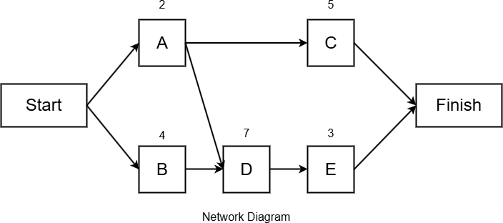

# What is the purpose of the precedence diagram method?

The Precedence Diagram Method (PDM) is a project management tool designed to create project schedules by visually representing tasks, their durations, and the relationships

between them. The primary purpose of PDM is to organize and sequence project activities effectively, ensuring that all dependencies are clearly understood and accounted for.

Purposes of PDM:

1. Define Task Dependencies:
   * PDM shows the logical relationships between tasks (e.g., which tasks must be completed before others can begin). This ensures proper sequencing and avoids scheduling conflicts.
2. Visualize the Critical Path:
   * By identifying the critical path, PDM highlights the sequence of tasks that directly impact the project’s completion time. This helps in prioritizing tasks that cannot afford delays.
3. Enhance Scheduling Accuracy:
   * With clear task relationships and dependencies, PDM enables more accurate and realistic project timelines.
4. Identify Flexibility with Float:
   * PDM allows project managers to determine float (slack) for tasks, identifying which ones have flexibility without delaying the overall project.
5. Support Resource Management:
   * By providing a detailed overview of task relationships and timelines, PDM assists in allocating resources efficiently to avoid bottlenecks.
6. Facilitate Communication:
   * The visual nature of PDM helps project teams and stakeholders understand the project structure and timelines, improving collaboration and decision-making.
7. Draw the precedence network diagram and Gantt Chart using MS Project.

|  |  |  |
| --- | --- | --- |
| Task Name | Predecessors | Duration |
| A |  | 20 days |
| B | A | 40 days |
| C | A | 20 days |
| D | B,C | 30 days |
| E | C | 10 days |
| F | D,E | 30 days |
| G | E | 10 days |
| H | F,G | 10 days |

Gantt Chart

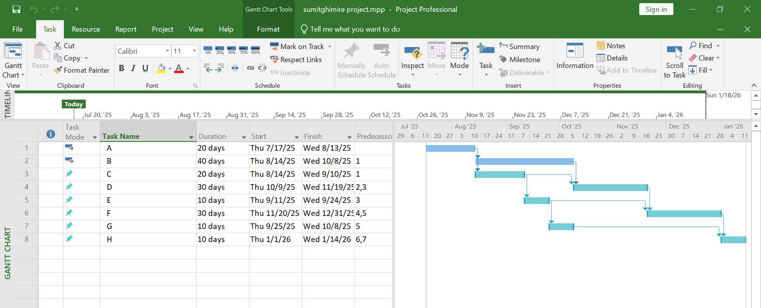

Precedence Network

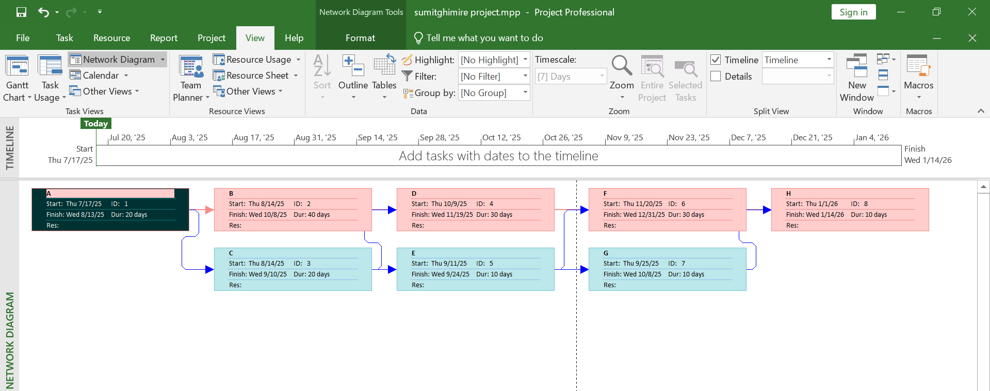

1. Draw the precedence network diagram and Gantt Chart using MS Project.

|  |  |  |
| --- | --- | --- |
| Task Name | Predecessors | Duration |
| A |  | 5 days |
| B |  | 1 days |
| C | A | 2 days |
| D | A | 3 days |
| E | A | 2 days |
| F | C | 3 days |
| G | D | 4 days |
| H | B,E | 2 days |
| I | H | 1 day |
| J | F,G,I | 1 day |

Gantt Chart

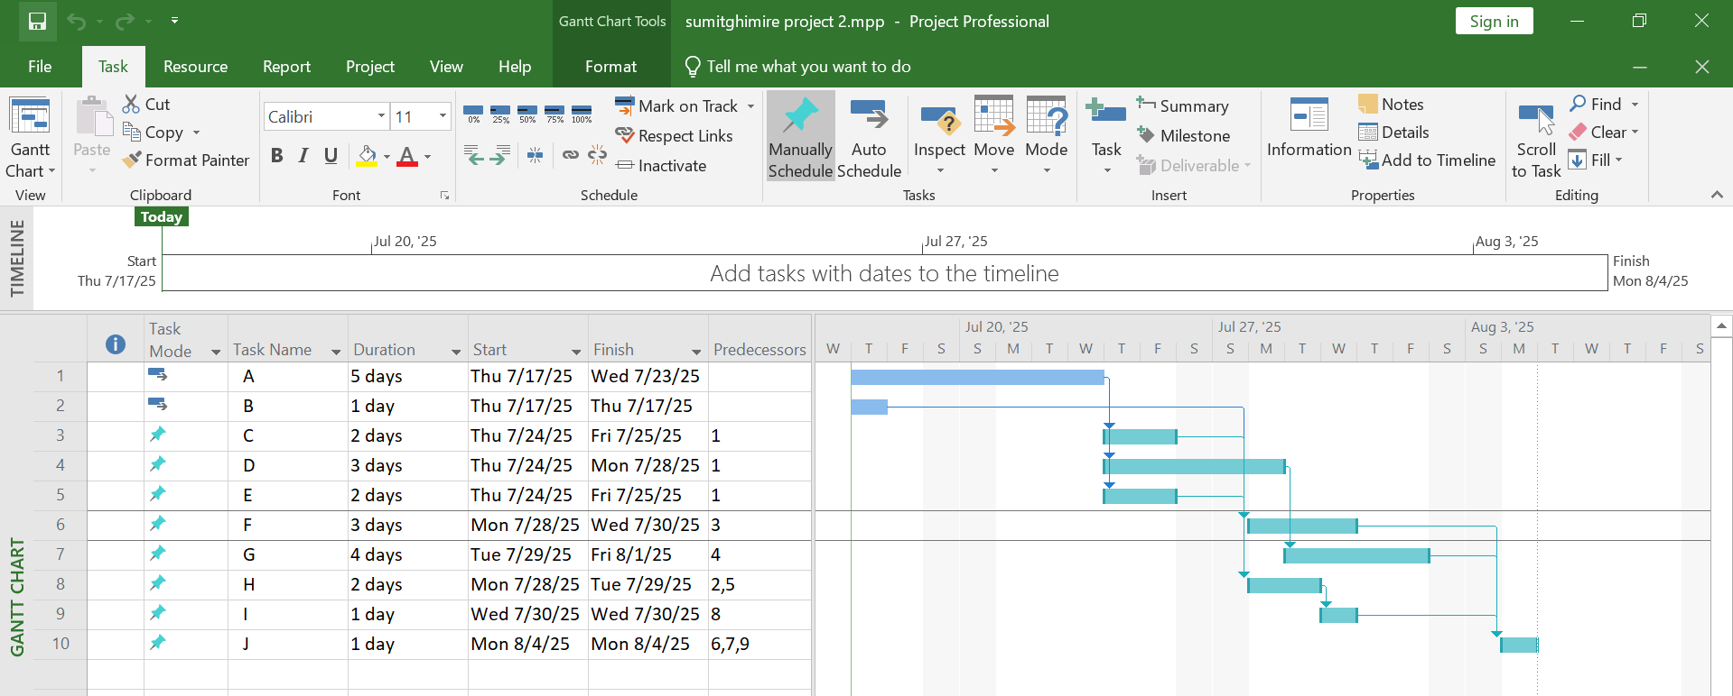

Precedence Network

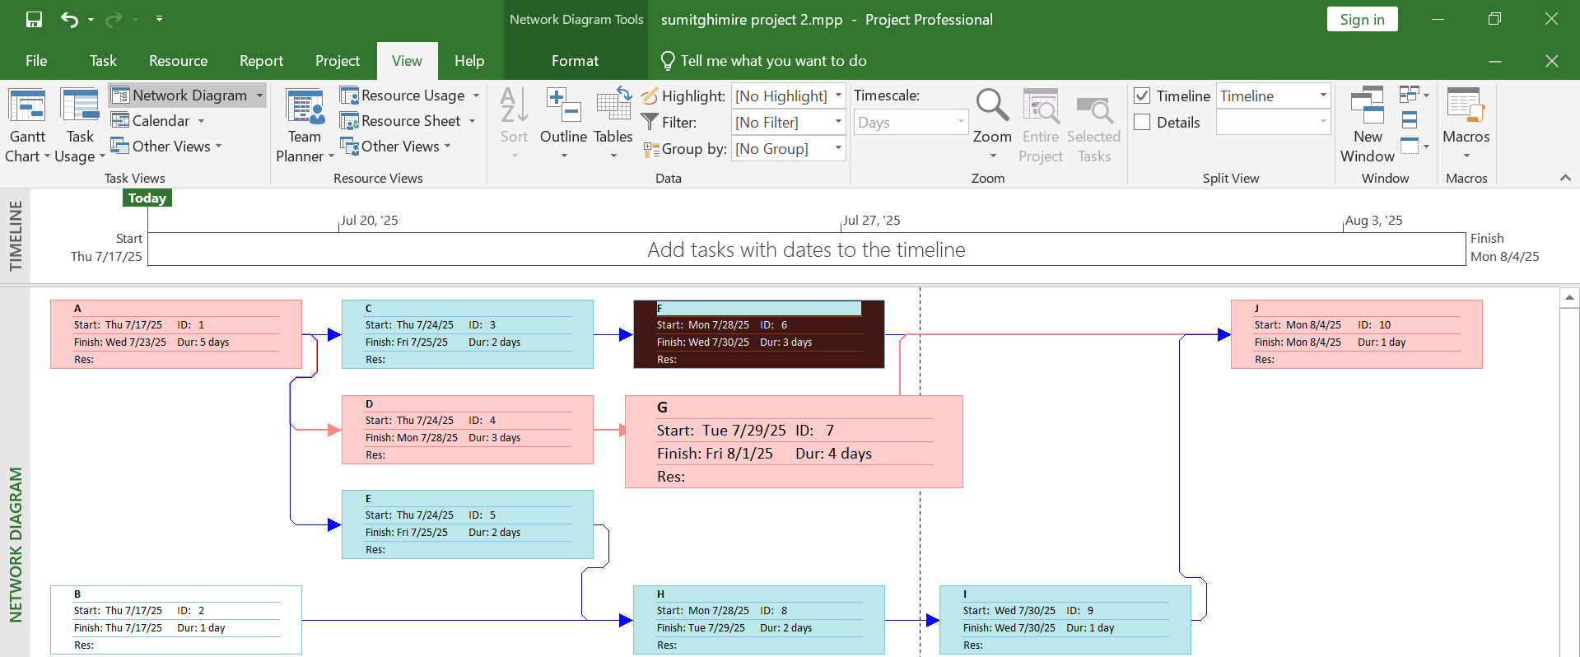

1. Draw the precedence network diagram and Gantt Chart using MS Project.

|  |  |  |
| --- | --- | --- |
| Task Name | Duration (weeks) | Predecessors |
| 1 | 2 |  |
| 2 | 3 | 1 |
| 3 | 3 | 2 |
| 4 | 7 | 2 |
| 5 | 6 | 2 |
| 6 | 1 | 3,4 |
| 7 | 5 | 4,5 |
| 8 | 4 | 6,7 |
| 9 | 8 | 7 |
| 10 | 2 | 8,9 |

Gantt Chart

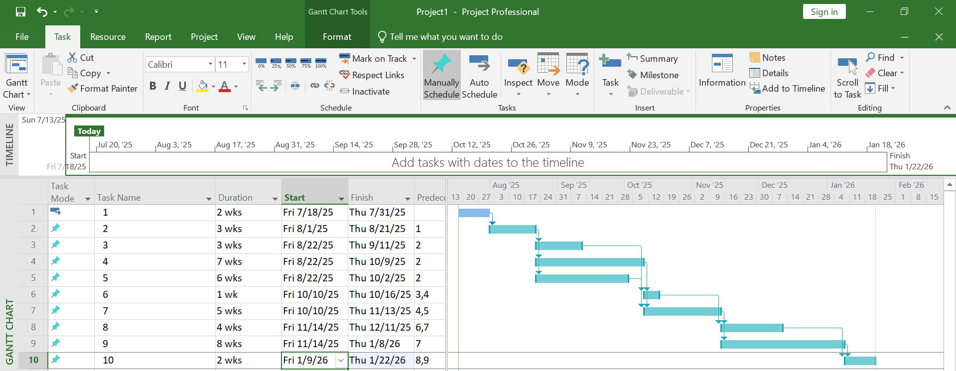

Precedence Network

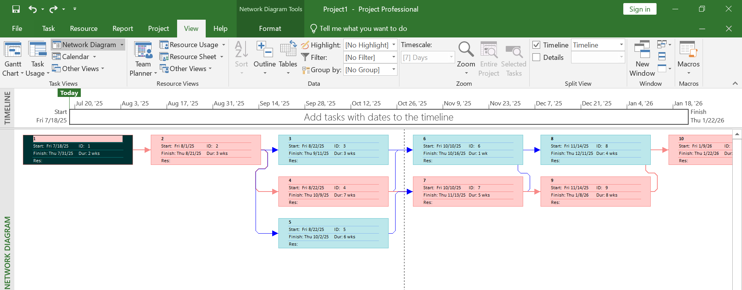

1. Draw the precedence network diagram and Gantt Chart using MS Project.

|  |  |  |
| --- | --- | --- |
| Tasks | Precedents | Duration |
| A |  | 7 days |
| B |  | 9 days |
| C | A | 12 days |
| D | A,B | 8 days |
| E | D | 9 days |
| F | C,E | 6 days |
| G | E | 5 days |

Gantt Chart

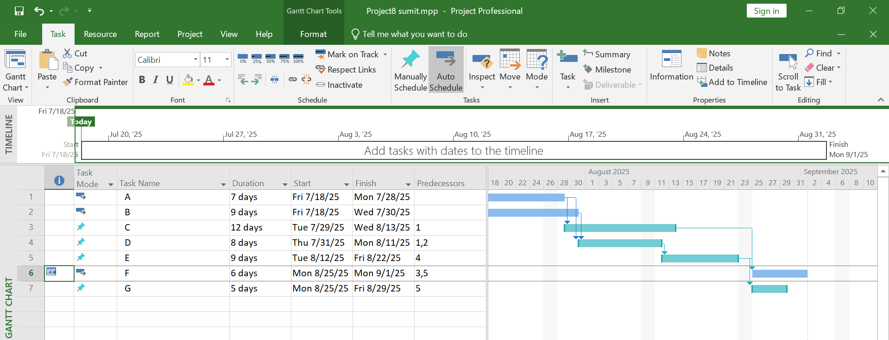

Precedence Network

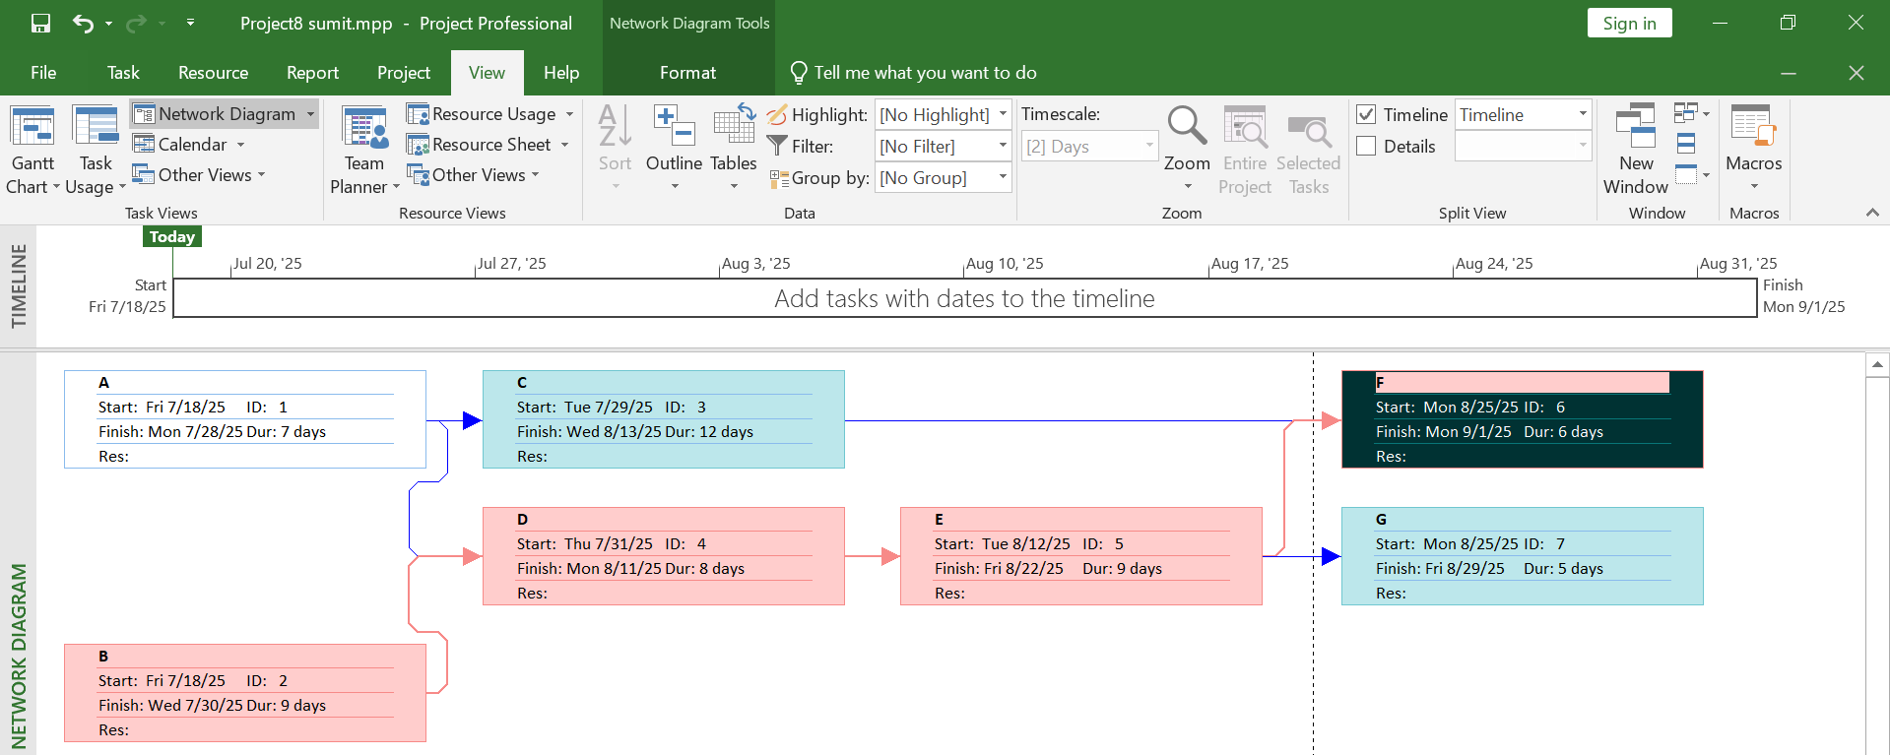

1. Firstly, define the different activities of your project that you made in the 6th semester.

Then, assign appropriate durations to each activity. Afterward, draw the precedence network diagram and Gantt Chart using MS Project.

Below is the list of tasks for my 6th semester project.

|  |  |  |  |
| --- | --- | --- | --- |
| Task Label | Task Name | Duration | Predecessors |
| A | Requirements Gathering & Figma  Design | 7 days |  |
| B | Backend Coding | 25 days | A |
| C | Frontend Coding | 34 days | A |
| D | Api Integration | 20 days | B |
| E | Payment Integration | 3 days | B |
| F | Testing | 50 days | B,C,D,E |

The start date for first task i.e. A was Monday 7/18/2025. Gantt Chart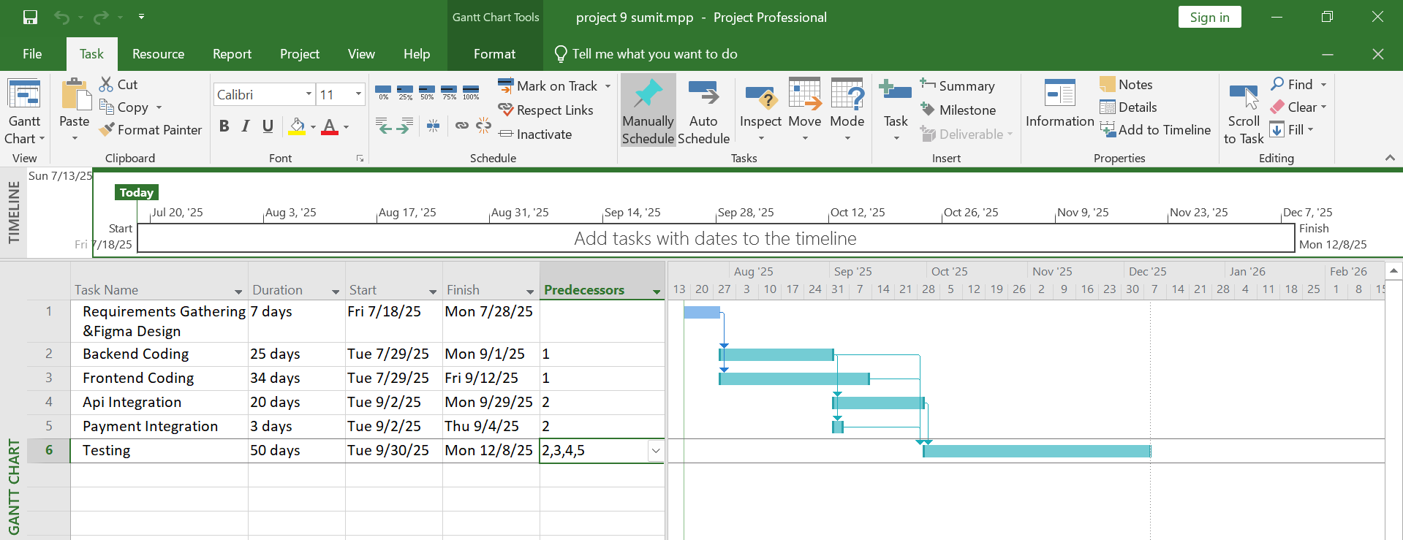

Precedence Network

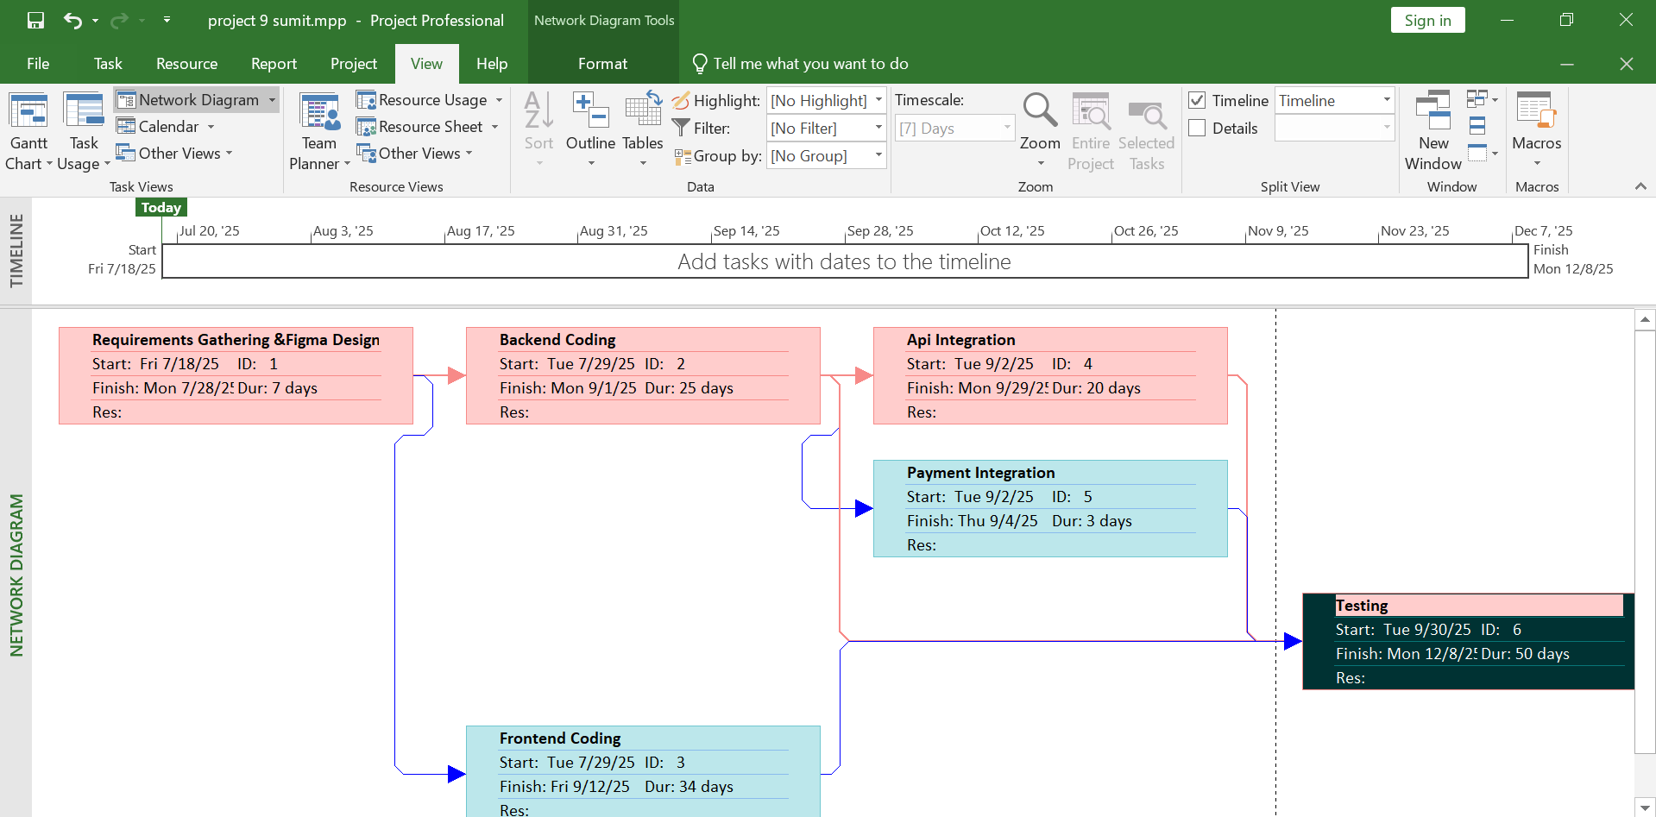

1. Draw the precedence network diagram and Gantt Chart using MS Project.

|  |  |  |
| --- | --- | --- |
| Task Name | Duration (months) | Predecessors |
| P | 10 | - |
| Q | 4 | - |
| R | 3 | P |
| S | 5 | Q |
| T | 1 | R |
| U | 5 | Q |
| V | 4 | - |
| W | 6 | T, V |
| X | 7 | R |
| Y | 3 | X, U |

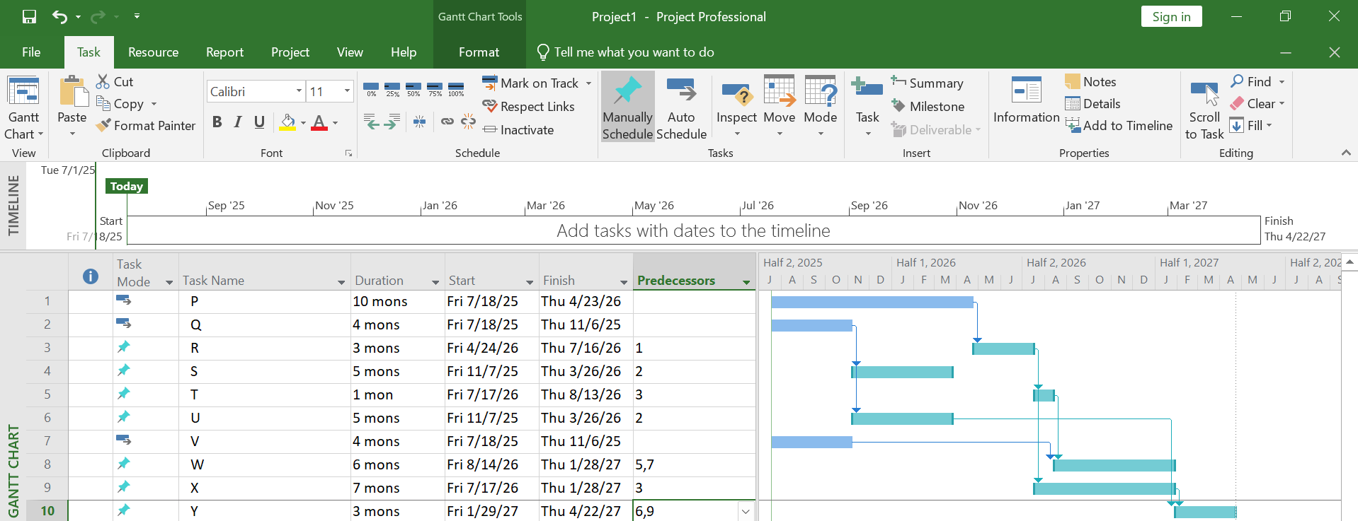Gantt Chart

Precedence Network

